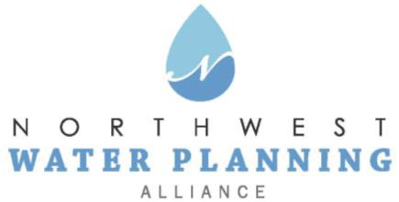

Technical Advisory Committee

https://zoom.us/meeting/register/tJ0tcOioqjMvG9L7igdfkb_ph2fXDwIqt_vi
After registering, you will receive a confirmation email containing information about joining the meeting.
July 27, 2021
10:00 am
Agenda

- NWPA Welcome and Introductions

- Agenda Changes and Announcements

- Approval of June Meeting Minutes

- General Discussion on Current Water Topics in the NWPA Area – All

- Presentation: “USGS Next Generation Water Observing Systems and the Illinois River Basin,” Jim Duncker, Illinois River Basin Coordinator, USGS

- Updates:
  - Sensible Salting Committee
  - CMAP
  - ISAWWA
  - MPC
  - ISWS
  - IDNR
  - USGS

- Other Business
  - Pending Legislation and Regulations
  - Conservation Foundation
    - 319 Grant and the Salt Smart Collaborative Program

- Next Meetings:
  - September 28, 2021: Join us for a presentation by Carrie Jennings, Research and Policy Director of Freshwater, a non-profit organization working in Minnesota
  - NO MEETING IN AUGUST

