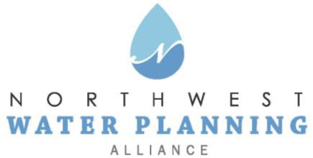

Technical Advisory Committee
November 23, 2021
10:00 am

Online:
Register in advance
You will receive a confirmation email containing online meeting details

Agenda
- NWPA Welcome and Introductions

- Agenda Changes and Announcements

- Approval of October Meeting Minutes

- General Discussion on Current Water Topics in the NWPA Area – All

- Presentation: "Sustainable yield estimates,” Daniel Abrams, ISWS

- NWPA Sustainability Plan

- Updates:
  - Sensible Salting Committee
  - CMAP
  - ISAWWA
  - MPC
  - ISWS
  - IDNR
  - USGS
  - Sugar Grove Water Authority

- Other Business
  - Pending Legislation and Regulations

- Next Meeting:
  - January 25, 2022

