Technical Advisory Committee
Zoom Meeting
July 27, 2021
Meeting Minutes
Present: Peter Wallers, MWCOG; Nora Beck, CMAP; Jim Duncker, USGS; Faye Sinnott, FC/SCWP; Jerry Elliott, SGTWA; Brad Merkel, Village of Sugar Grove; Austin McFarlane, Lake County Public Works; Jodie Wollnik, Kane County; Kevin Fescke, Village of Barrington; Natalie Karney, Village of South Barrington; Derek Hiland, DeKalb County; Matt Asselmeier, Kendall County; Walt Kelly, ISWS; Jeff Babich, SGTWA; Mark Wolf, Village of Montgomery; David Schumacher, City of Aurora; Chris Lemke, Village of Sugar Grove; Amy Gahala, USGS; Ryan Anderson, Village of Minooka; Judith Thomas, USGS; James Pew, CMAP Intern; Gary Clark, Retired IEPA; Kelsey Pudlock, CMAP; Nora Beck, CMAP; Scott Kuykendall, McHenry County; Kimberly Saunders, BACOG; Hanna Miller, Conservation Foundation; Tim Zasada, Village of Oswego; Margaret Schneemann, IISG; Angie Smith, EEI

Peter Wallers called the meeting to order at 10:01 A.M.

Welcome, Roll Call and Introductions: Pete (MWCOG) welcomed everyone to the meeting.

Agenda Changes and Announcements: Pete (MWCOG) stated no changes at this time.

Approval of June Meeting Minutes: Scott (McHenry County) made a motion to approve. David (Aurora) seconded. Minutes approved.

General Discussion on Current Water Topics in the NWPA Area: Pete (MWCOG) opened the group for discussion. Dave (Aurora) reported it’s been helpful to get some rain. Things are running status quo at the moment.

Presentation: “USGS Integrated Water Science”: Pete gave a quick introduction for Jim and thanked him for joining the group today. It’s a new program that will focus on the Illinois River Basin for 10 years for USGS. The program is a regional focus for intensive observation, assessments……. The Illinois River Basin is 28,756.6 square miles, covers 44% of the state, 90% of the state’s population; drainage basin extends into Wisconsin, Indiana….. It has major sub-basins; drainage basin extends into Wisconsin Indiana and a very small portion of southwestern Michigan; extensive monitoring both the Upper and Lower Illinois River Basin; large urban/suburban component in the upper part of the basin……
The Illinois water way profile view
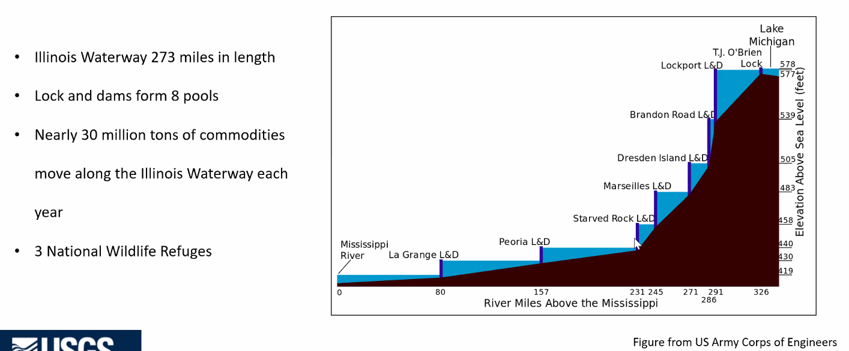

He sits in the Next Generation Water Observing System (NGWOS) department or the observation department. The information will be used to enhance the predictive models that are shared with the general public. The NGWOS collects real time data on water quality and quality in more affordable, rapid and intensive ways than has previously been possible. The flexible monitoring approach enables USGS networks to evolve with new technology and emerging threats.
Other components of the program include: Integrated Water Availability Assessments (IWAA), Integrated Water Prediction (IWP) and National Water Information Systems (NWIS) Modernization; National Water Dashboard.
The Illinois River Basin IWS insights and opportunities – it is estimated to be one of the largest geographic source of nutrients to the Gulf of Mexico. The process will improve understanding of nutrient sources and climate and land use change.
Components of the integrated water science basins: catalog existing observational networks, models and data repositories and identify monitoring and knowledge gaps; establish integrated set of fixed and mobile monitoring assets in the water, ground and air to fill data gaps; conduct targeted hydrologic research to fill knowledge gaps; use new data and knowledge to develop improved basin models; use models to asses past, current, and future water availability – including water quantity, quality and use.
Advanced Water Models require high-density data – nearly 30 million stream reaches in US; USGS operated about 11,400 stream gages. About 143,000 community supply wells and over 14 million domestic wells in USGS.
NGWOS approach is to increase spatial and temporal coverage for critical data. Ability to bring new state of the art technology tools to the monitoring project.
This is the basis of the work elements:
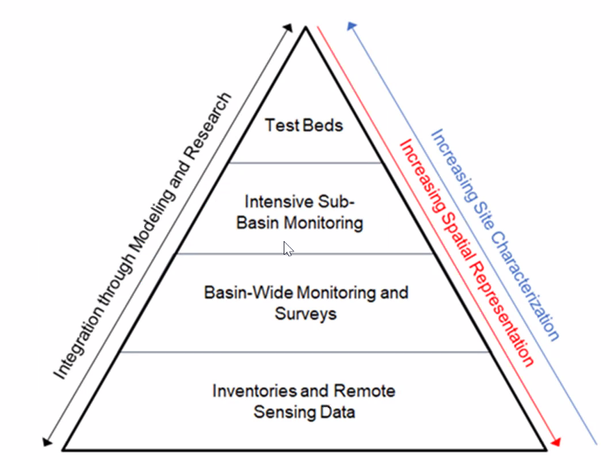
Some of the longstanding and newer issues with the basin include nutrients, emerging contaminants, harmful algal blooms, invasive species, urban flooding, flooding inundation, etc.
NGWOS timeline:
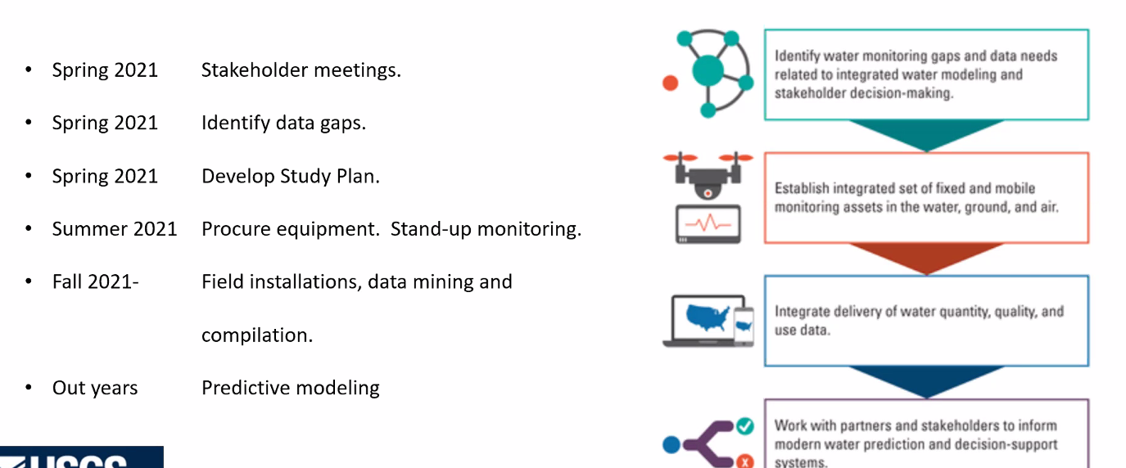
Jim will get the answer to the question: is USGS going to monitor Nitrous Oxide? (Faye Sinnott)
Future information can be shared within our group if Jim sends it to us. USGS is working together with ISWS H&H department.
https://pubs.er.usgs.gov/publication/sir20205041 - Study of trends in nutrient and soil loss in Illinois Rivers
Presentation: “Salt Smart Collaborative for Parking Lots and Sidewalks – Training and Certification Program”: Pete gave a quick introduction of Hanna (Conservation Foundation). Hanna gave a presentation on the 319 Grant and the Salt Smart Collaborative. Some updates to the Section 319 grant, worked with IEPA to incorporate flexibility. Will be hiring consultants to assist with grant tasks, such as: technical content review, increase readability, development of and translation into training modules, branding and graphics, IT needs as well. One of the first tasks will be to set-up a SSC Training Committee, first meeting is targeted for August 26th. Will be meeting with Scott to go through an initial review on the IL-based training manual. If interested in participating the SSC Training Committee, please contact Jennifer Hammer or Hanna to get on the list.
Upcoming training virtual winter deicing workshops in September and October: public roads – September 30th, October 5th and 12th.
Pete stated that the NWPA will support this initiative with a financial contribution and working out the details with Jennifer. Highly recommended reaching out to Turk to ask if he would sit on the committee.
Sensible Salting Committee (SSC) (Update): Scott (McHenry County) will be meeting with Hanna and Jennifer on Thursday to move this forward.
CMAP (Update): Nora (CMAP) reported that they are in the midst of the water supply planning forecasts. Partnered with Margaret Schneemann on this. Another project is inserting a water supply process into their comprehensive plans.
ISAWWA (Update): Pete (MWCOG) mentioned WATERCON2021 is happening August 9th-11th this year. There are a few COVID restrictions in place, but always a good event.

MPC (Update): Pete (MWCOG) reported that they are putting on the Drinking Water 1-2-3 Academy.

ISWS (Update): Walt (ISWS) reported that they are getting ready to start the synoptic readings. Will be focusing on the Chicago region, Boone, LaSalle Counties. Will be focusing on the static levels and the pumping levels. The other thing is going to try and focus on one aquifer well. Try to focus on the wells that are in the center of cone of depression. Will share results either later this year or early next year.

IDNR (Update): No Update

USGS (Update): Judith (USGS) reported that the McHenry Report will be finalized by the end of the year. Will be able to do a presentation on that later this year. Also, the NGOWA PFAS findings would be good to share with this group. Continuing work with IEPA on the PFAS initiative.

SGTWA (Update): Jerry (SGTWA) No Update.

Other Business: Pete (MWCOG) No Update.

TAC Group: We are planning to go back to in-person meetings in September at this time. We will try to make it a hybrid meeting. If there are comments please reach out.

Scott (McHenry) cool project with McHDOT to initiate a sign program for watersheds within the County. Every County road will have a sign that shows the water bodies with the top showing the stream being crossed and where the water goes to. Can you send some photos so we can post them on the website?

The presenter will be Cary Jenkins out of Fresh Water out of Minnesota for the September meeting.

Kimberly (BACOG) just completed the water monitoring for the aquifer water level. Will make sure to share the information. Pete (MWCOG) if you want to present at a future meeting just let us know.

The next meeting will be held on September 28th, 2021 at 10 AM will be in-person and via Zoom. The meeting was adjourned at 11:32 AM.

Submitted by ______________________________ Angie Smith, EEI

